Project Three: Data Validation Report
Adrian Aguilar
Southern New Hampshire University
DAT 325: Data Validation: Quality and Cleaning
Professor Sharmila Prasad Kundami
October 17, 2025

Validations of Data Sets
Table 1. Counts of Rows and Columns in Each Dataset
Data Set | Row Count | Column Count
Cleaned firm’s data set | 42 | 10
Your company’s data set | 105 | 17
Merged data set | 105 | 24

Table 2. Minimum, Maximum, and Average Values of Quantitative Variables
Data Set | Minimum | Maximum | Average
Age | 21 | 60 | 39.5
Days Employed | 0 | 1056 | 370.3

Age

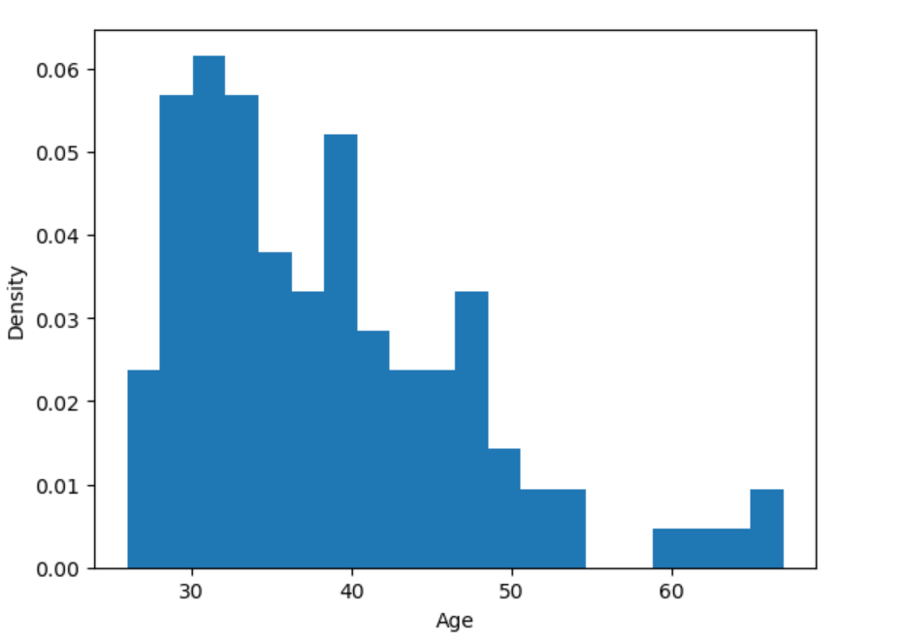
Figure 1. Age distribution showing a normal range between 25 and 50 years old with no major outliers.
No significant outliers were found in Age. The data ranged from 21 to 60 years, which is within the range of employee demographics. Therefore, no outlier values were removed from the Age dataset.

Days Employed

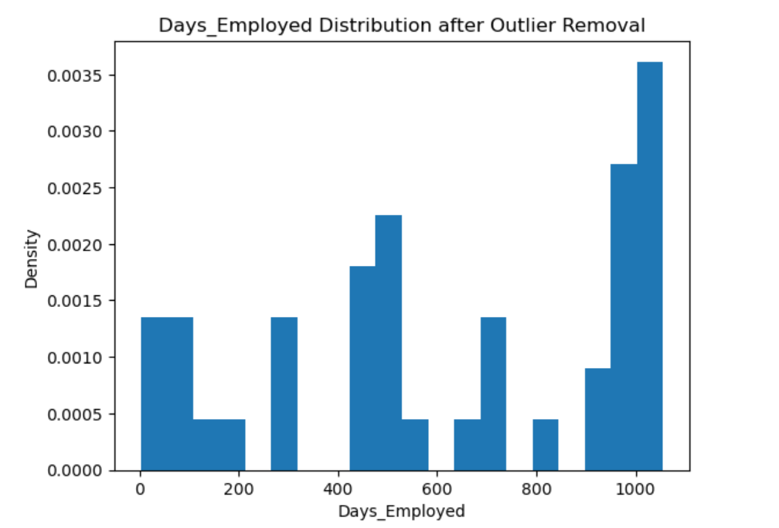
Figure 2. Days_Employed distribution after cleaning; outliers and negative values were removed, leaving a maximum of 1,056 days.
The Days_Employed variable had several outliers and invalid values. Negative values and an extreme outlier (approximately 365,243 days) were removed. After cleaning, the maximum value was reduced to 1,056 days, confirming the removal of outliers.

Summary
The data validation process involved a series of cleaning, transformation, and verification steps. These were designed to ensure both datasets were accurate, consistent, and ready for integration. First, missing values in key fields, such as Days_Employed and Citizen_Desc, were addressed. The median was used to replace missing Days_Employed values to preserve the overall distribution. Records missing Citizen_Desc were removed to maintain data integrity. Incorrect entries, including negative Days_Employed and invalid citizenship descriptions, were filtered out. Outlier detection identified extreme Days_Employed values over 1,056 days. These outliers were removed to avoid statistical distortion.
After completing the cleaning phase, transformation steps were applied to align both datasets for merging. The firm’s Employee_Name field was split into First_Name and Last_Name to match the company’s structure. This enabled an accurate left join on Last_Name, First_Name, and DOB. The merged dataset produced 105 rows and 24 columns, confirming that all company records were matched where applicable.
These validation and transformation steps ensured that all variables were accurate, standardized, and free from duplication or anomalies. The final dataset is complete, reliable, and of high quality. It is ready for further analysis and confident decision-making without compromising data integrity.

